DIGITA MARKETING

PROJECT WORK

PROJECT TITLE: Comprehensive Digital Marketing For Hyundai Motor Company.

NAME: p.Sripathi reddy

TEAM ID: LTVIP2025TMID19527

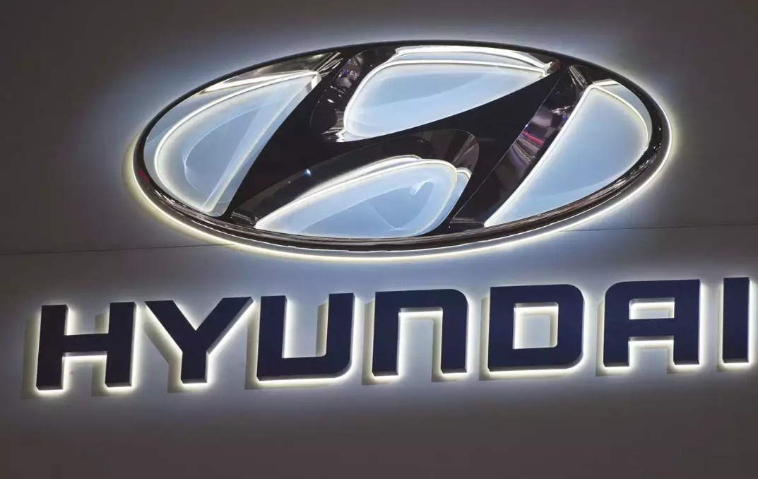

Brand Study

1. **Brand Positioning**

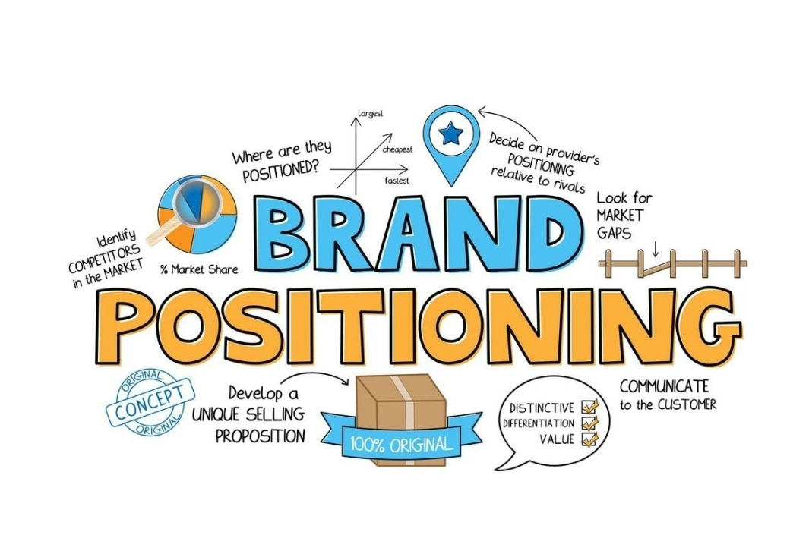

**:**Hyundai Motor Company is a South Korean multinational automotive manufacturer that positions itself as a innovative and reliable brand.

1. ***Target Audience***:



Individuals and families seeking reliable, feature-packed, and affordable vehicles.

3. Hyundai's focus on innovative technology, safety features, and eco-friendly vehicles sets it apart from competitors.

Competitor Analysis

1. ***Direct Competitors:***



Toyota, Honda, Ford, Volkswagen, and Nissan.

1. ***Indirect Competitors***

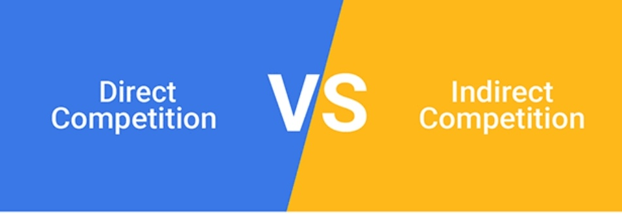

: Electric vehicle (EV) manufacturers like Tesla and luxury brands like Mercedes-Benz.

***3.Competitor Strengths and Weaknesses:***



- Toyota: Strong brand reputation, reliable vehicles (strengths); limited EV offerings (weakness).

- Honda: Innovative technology, fuel-efficient vehicles (strengths); limited luxury offerings (weakness).

Buyer's/Audiences Persona



*1.* ***Demographics***: Age 25-50, middle to upper-middle-class individuals and families.

2***. Psychographics:*** Values reliability, safety, innovation, and eco-friendliness.

3**. Pain Points:** Seeking a trustworthy vehicle brand, concerned about environmental impact, and desires innovative features.

4. ***Goals***: Purchase a reliable, feature-packed, and eco-friendly vehicle.

SEO & Keyword Research



1***.Primary Keywords***: "Hyundai cars," "Hyundai SUVs," "electric vehicles," "eco-friendly cars."

2. **Secondary Keywords**: "Hyundai reviews," "Hyundai prices," "Hyundai dealerships."

3. ***Long-Tail Keywords***: "Hyundai electric SUVs," "Hyundai hybrid cars," "Hyundai family vehicles."

SEO Audit

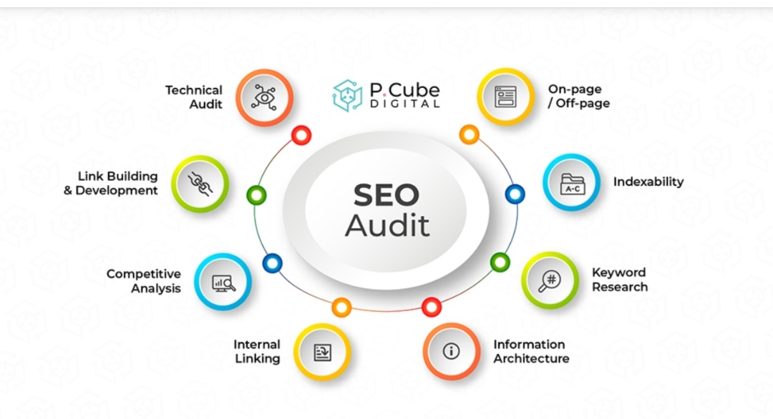

1**. Technical SEO**: Ensure website is mobile-friendly, has fast loading speeds, and is secure (HTTPS).

2***. On-Page SEO***: Optimize meta tags, titles, and descriptions for target keywords.

***3. Content Quality:*** Ensure high-quality, engaging, and informative content.

On Page Optimization

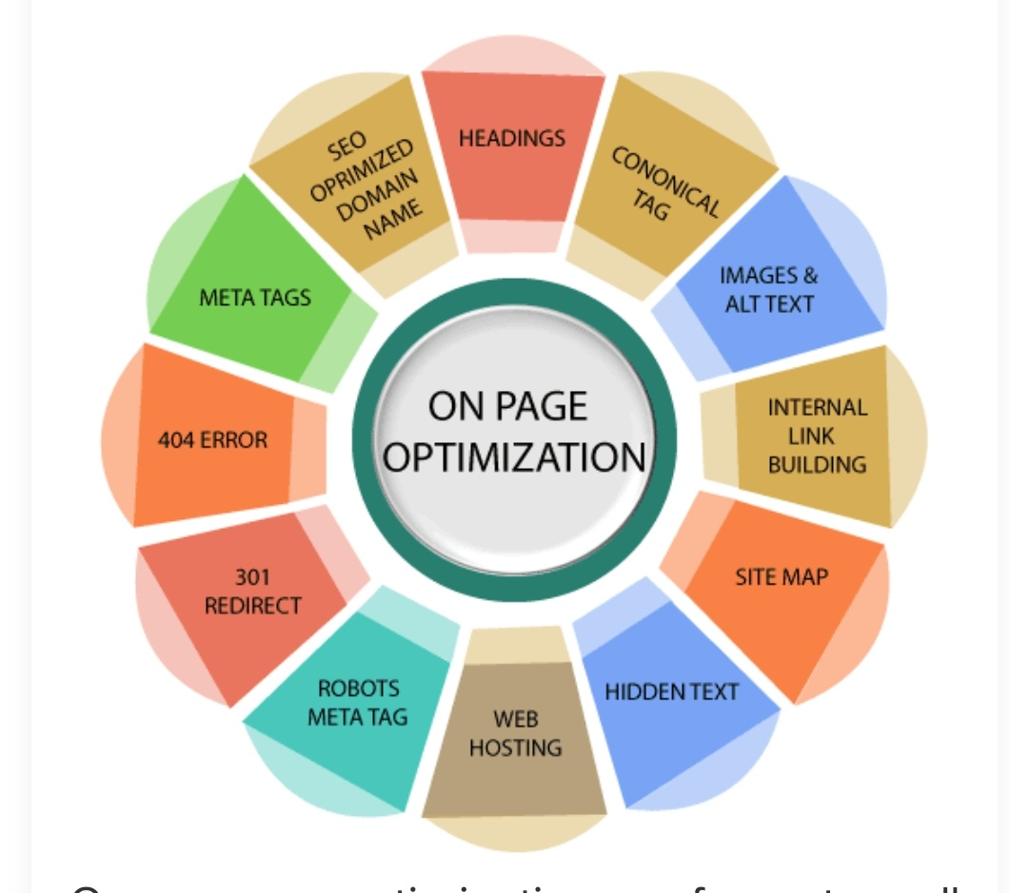

1. **Optimize Meta Tags**: Update meta titles, descriptions, and keywords for target pages.

**2. Header Tags:** Organize content with header tags (H1, H2, H3, etc.).

3**. Image Optimization**: Compress images, add alt tags, and descriptive text.

**Content Ideas And Marketing Strategies**

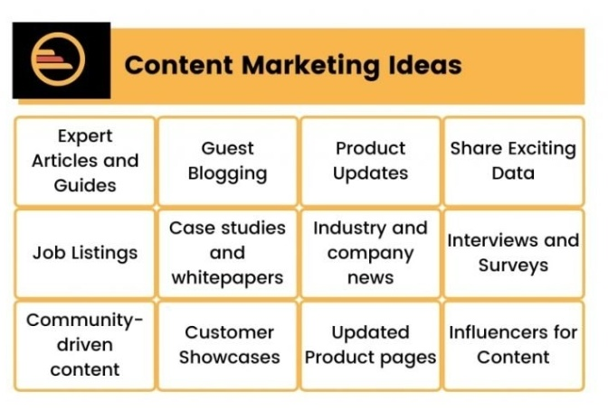

1. **Blog Posts**: "Top 5 Eco-Friendly Hyundai Models," "Hyundai's Innovative Safety Features," "Why Choose Hyundai for Your Family Vehicle."

2**.Social Media Campaigns**: Share engaging content (images, videos, testimonials), utilize hashtags, and collaborate with influencers.

3**. Email Marketing**: Send newsletters with exclusive offers, new model releases, and event invitations.

4**. Influencer Partnerships**: Collaborate with eco-conscious, family-focused, and automotive influencers.

**Content Creation And Curation**

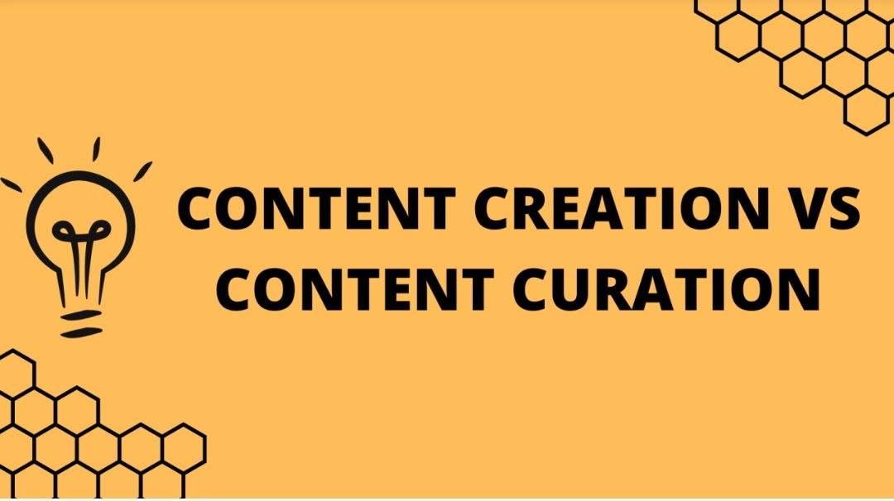

1**. High-Quality Visuals**: Develop engaging images, videos, and 360-degree views of Hyundai vehicles.

**2.Customer Testimonials**: Encourage satisfied customers to share their experiences with Hyundai vehicles.

3**. Industry News and Updates:** Share relevant news, trends, and updates about the automotive industry.

By implementing this comprehensive digital marketing plan, Hyundai Motor Company can enhance its online presence, attract potential customers, and drive sales.